**JDBC:**

Jdbc ia an API (Application programming interface) used to communicate Java application to database in database independent and platform independent manner. It provides classes and interfaces to connect or communicate Java application with database.

Jdbc ia a part of JDK software so no need to install separate software for jdbc API

Jdbc API consists of two packages

* java.sql package
* javax.sql package

**Why use jdbc**

* In earlier days for communicate front end application to database, front-end application used a set of function given by database vendor, to connect with a database.
* Even today C and C++ application are connecting with oracle database using a set of function given by oracle corporation in a **orcl.h** header file.
* But problem with the above communication is a front end application become as a database dependent application because every database vendor give its own set of function for communication.
* To overcome the database dependent problem ODBC (Open database connectivity) community formed by Microsoft with Simba technologies.
* ODBC community has provided ODBC API, to connect with any database in a database independent manner.

**JDBC Architecture**:

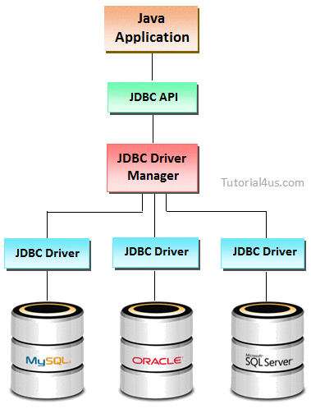

**Difference between ODBC and JDBC**

|  |  |  |
| --- | --- | --- |
|  | **ODBC** | **JDBC** |
| 1 | Odbc is platform dependent and database independent. | Jdbc is both platform and database independent. |
| 1 | Odbc implemented in C language with pointer. | Jdbc implemented in java without pointer. |

## Jdbc api

**Jdbc API** is a java API that can access any kind of tabular data and specific data stored in relational database management system (RDBMS).

### Packages

* java.sql package
* javax.sql package

## Classes In Jdbc

* DriverManager
* SQLException
* Types
* Date
* Time

## Interfaces In Jdbc

* Connection
* Statement
* PreparedStatement
* CallableStatementResultset
* ResultSetMetaData
* DatabaseMetaData
* Driver
* Blob
* Clob